**Efficient Development & Debugging**

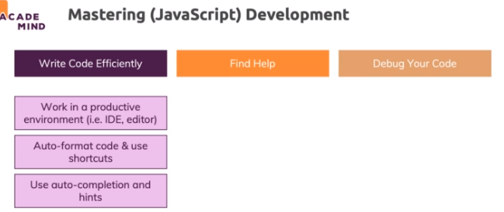

**Using Shortcuts**

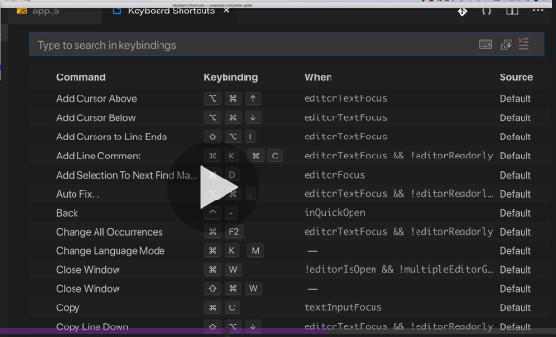

**Installing IDE Extensions**

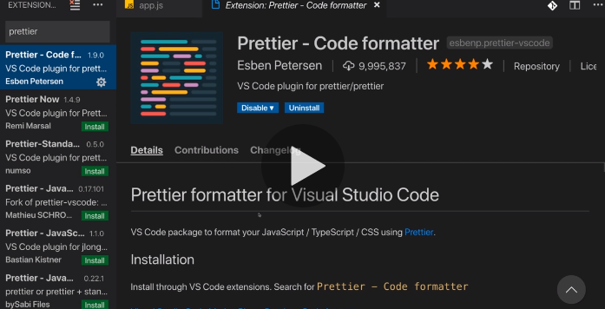

**Tweaking Editor Settings**

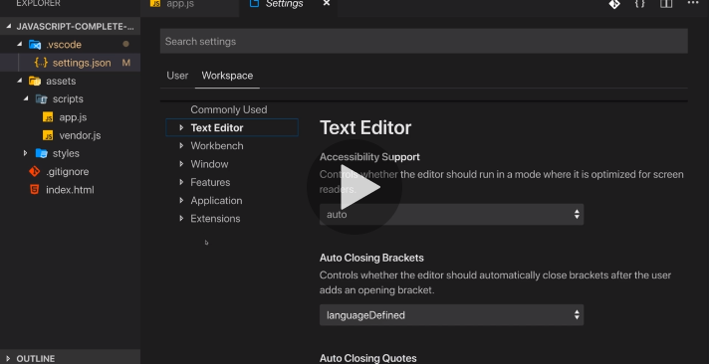

**Utilizing Different IDE Views**

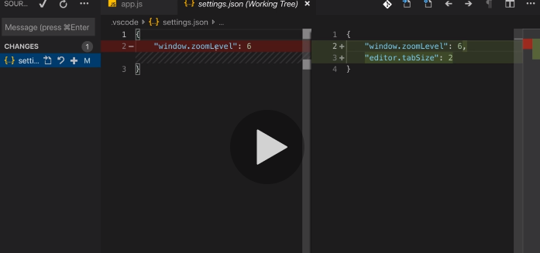

**Finding Help & Working with MDN**

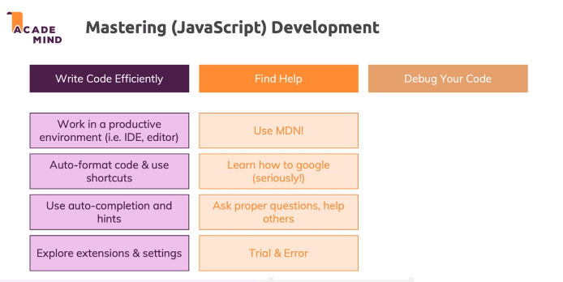

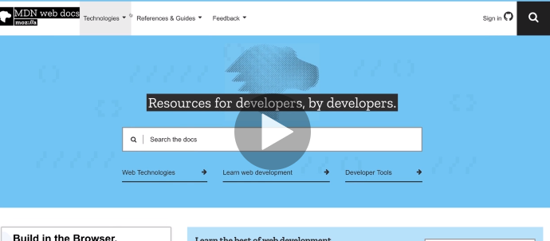

**The ECMAScript Standard**

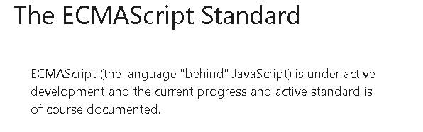

**Debugging JavaScript - An Overview**

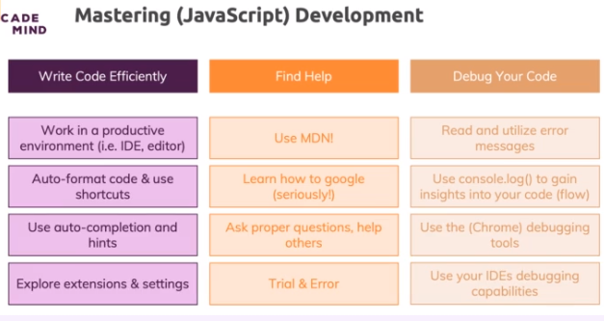

**An Error Message! No Reason To Panic!**

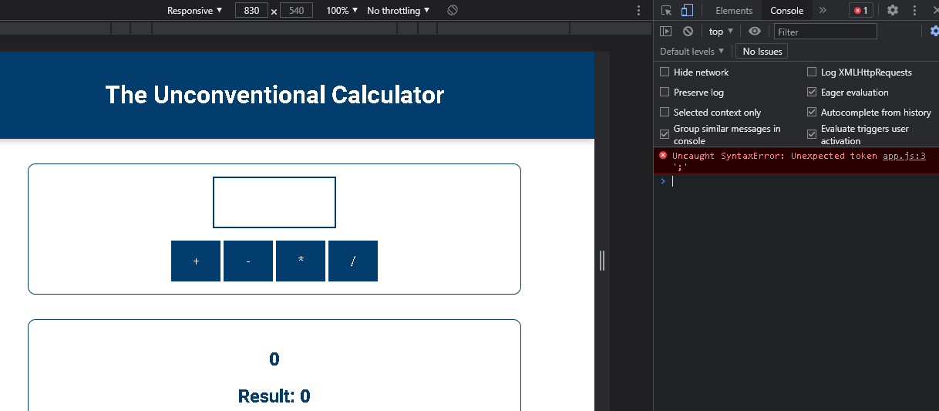

**Using console.log() to look "into the Code"**

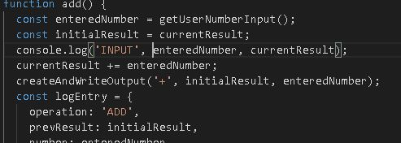

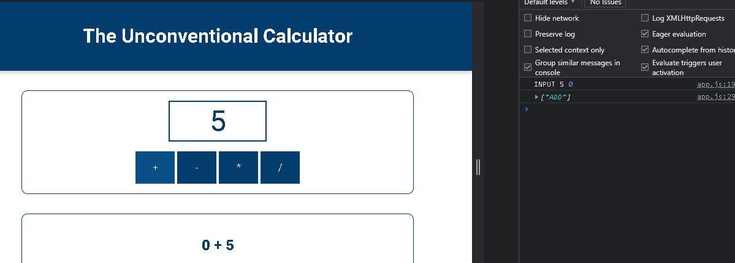

**Next-Level Debugging with the Chrome Devtools & Breakpoints**

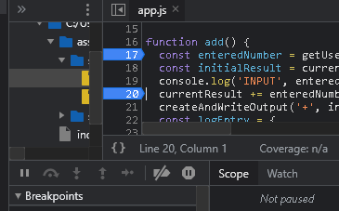

**Testing Code Changes Directly in the Devtools**

Codes can be altered and changed in the sources section of the Inspect element too

without affecting the actual code area of visual studio

**Debugging Code directly Inside VS Code**

